**FINAL PROJECT PART 2**

**1)Create a Conceptual Diagram/Schema for the database**

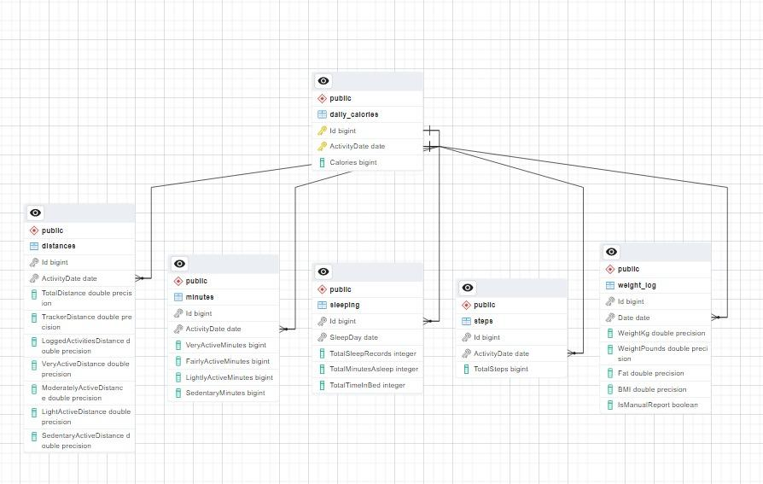

**Conceptual Diagram**

dailyActivity: This table records a user's daily activities, such as the total number of steps, distance traveled, active minutes, and calories burned. This main table is split into 4 tables(daily calories, steps, minutes, and distances) to understand the data better.

**Diagram structure :**

**The diagram contains six entities(/objects):**

* daily calories: This table keeps track of a user's daily calorie intake.
* steps: This table is a child table of daily calories and records the total number of steps taken by a user on a given day.
* minutes: This table, which is also a child table of daily calories, records a user's active minutes on a given day, broken down by type (very active, fairly active, lightly active, sedentary).
* distances: This table, like daily calories, is a child table that records the distance traveled by a user on a given day, broken down by type (total, tracker, logged activities, very active, moderately active, lightly active, sedentary).
* sleeping: This table stores a user's sleep data, such as total sleep records, total minutes asleep, and total time spent in bed.
* weight_log: This table contains data related to weight tracking. It includes columns for ID, Date, WeightKg, WeightPounds, Fat, BMI, and IsManualReport. The primary key of this table is a combination of the ID and Date columns. A foreign key constraint is present that references the daily_calories table.

All entities have a primary key that is made up of the combination of Id and ActivityDate and is used to establish relationships between them.

The daily calories table, in particular, is the parent table of steps, minutes, and distances. The foreign keys in these tables are Id and ActivityDate, which refer to the corresponding primary key in daily calories. The sleeping table contains a foreign key made up of Id and SleepDay that refers to the corresponding primary key in daily calories. A foreign key of Id and Date exists in the weight Log table, referencing the corresponding primary key in daily calories.

Overall, the ER Diagram structure indicates that the database is intended to capture and store a user's daily health and fitness data, such as activity, sleep, and weight.

The following are the relation types for the schema's tables:

* 1:1 (one-to-one): The dailyActivity and daily calories, steps, minutes, and distances tables have a one-to-one relationship. Every row in the dailyActivity table corresponds to one row in every other table, and vice versa. The daily calories and sleeping, steps, minutes, weight log, and distances tables have a one-to-one relationship. Every row in the daily calories table corresponds to one row in every other table, and vice versa.
* Many-to-one (N:1): In this schema, there is no explicit many-to-one relationship.
* One-to-many (1:N): In this schema, there is no explicit one-to-many relationship.
* Many-to-many (N: N): In this schema, there is no explicit many-to-many relationship.

**2)Database**

**Database Constraints:**

Several constraints exist in the database to ensure data integrity.

The **primary keys** in the dailyActivity, daily calories, steps, minutes, and distances tables ensure uniqueness. **Foreign key** constraints reference the daily calories table in the steps, minutes, and distances tables. These constraints ensure that the data in these tables are consistent.

All columns in the tables are set to **NOT NULL**, ensuring that no null values appear in the tables.

**Do you plan on creating views, functions, and procedures?**

Yes, we have planned to use views and functions for tasks such as finding average steps, average distance, average sleep taken, and average calories for each person so that we can gain more insights from the visualizations. While developing the project, we plan on creating more views and functions based on the requirement for the application.

**3)Write code to create a database and build queries. Your task is to create a reproducible code.**

The SQL file attached contains all of the codes for this section.

**4)Assessment Table: Add your individual assessment/evaluation for your work.**

**Provide your personal assessment/evaluation [Are you satisfied with the task completion (scale 1-10), teamwork, time commitment, what could be done better.**

**Assessments**

Team Lead - Shivani:

| **Category** | **Comments** |
| --- | --- |
| Task Completion | 9.5/10. Completed all the tasks with ease and no last-minute changes or workarounds |
| Teamwork | Amazing team. Each one of us had a great understanding I felt. Consider it task division or picking up tasks it was very easy for me, and I felt very comfortable giving any feedback as well |
| Time Commitment | Each of us equally put in the effort and all the tasks were completed before the deadline. So all team members were punctual and diligent |
| Improvements | Better time management would have helped us to work more relaxed. |

Team Member – Abhigna Deverasetty:

| **Category** | **Comments** |
| --- | --- |
| Task Completion | 9.9/10. We were always ahead of the plan that we created |
| Teamwork | Loved this team and working with each one of them. Both were cooperative, friendly, and helpful. Tasks were divided equally and completed energetically |
| Time Commitment | As everything was done before planned, I can easily say all of us put in the effort and were punctual with the task completed before the deadline. |
| Improvements | Nothing at this point from my side |

Team Member - Preetham Vinnamala:

| **Category** | **Comments** |
| --- | --- |
| Task Completion | On a scale of 10, my score would be 9.3. |
| Teamwork | Great teamwork. Everyone was proactive and picked up the tasks on the go. There was never a scenario where we had a bad retrospective meeting. The team lead was amazing she always kept the team atmosphere motivated. |
| Time Commitment | All the members were committed, and equal efforts were put in. |
| Improvements | Improvement that I can only think of is a little early start |